DG ENVIROMENT
E-PRTR Dissemination and new tools
CONTRACT Nº 070302/2009/549601/SER/C4



Guide on MAINTAINING OUTLIERS to be used in the Complementary validation

Version | 3
Authors | Alberto Telletxea
Revised by | German Garcia de Guturbay

index
1 Introduction 3
2 Outliers Codelist XML 4
2.1 Location of the “Outliers” XML code list file 4
2.2 Description of the XML Code List files 4
2.2.1 AirThresholds: 5
2.2.2 WasteTransfersThresholds: 5
2.2.3 WaterThresholds: 6
3 E-PRTR Nuts Envelope Code List 7
3.1 Location of the “E-PRTR NUTS” XML code list file 7
3.2 Description of the XML Code List file 7
4 How to Update Code Lists 8
4.1 Editing process for outliers code lists 8
4.2 Editing process for NUTS code list 9
4.2.1 Calculation of NUTS geographical envelopes: 9
4.3 Upload process into CDR 13

Introduction
The aim of this document is:
- to guide on how to update the outliers codelist for the “Complementary Validation: Outliers” in the operational environment.
- to guide on how to update the EPRTR Nuts envelope codelist for the “Complementary Validation: Coordinates and NUTS check ” in the operational environment.

Outliers Codelist XML

Location of the “Outliers” XML code list file
At this stage the “Outliers” validation rule uses three different XML:
- EPRTR_AirThresholds.xml
- EPRTR_WasteTransferThresholds.xml
- EPRTR_WaterThresholds.xml

The XMLs can be found in the CDR Eionet at:
http://converterstest.eionet.europa.eu/do/uplXmlFiles

Description of the XML Code List files
The XML follows the same structure of the spreadsheets files provided by DG Environment where the pollutants for Air, Water and Waste transfer were listed using the following parameter columns:
- Activity Code
- PollutantCode/WasteTypeCode
- Value

Below the different XML schemas in used are described:
<rsm:ActivityCode>9.(e)</rsm:ActivityCode>
<rsm:PollutantCode>PM10</rsm:PollutantCode>
<rsm:Value unitCode="TNE">3920</rsm:Value>
</rsm:AirThreshold>

AirThresholds:
Depicted in red are the values assigned by the user to the XML, elements inner text values and elements attributes (e.g. Value – attribute “unitCode”).
XML Schema:
<?xml version="1.0" encoding="UTF-8" ?>
- <rsm:AirThresholds xmlns:rsm="urn:eu:com:env:prtr:data:standard:2">
- <rsm:AirThreshold>
<rsm:ActivityCode>Annex I activities of the facility</rsm:ActivityCode>
<rsm:PollutantCode>Waste Type Code (e.g. HWIC)</rsm:PollutantCode>
<rsm:Value unitCode="Unit used for the measurement (e.g. TNE - tones & KGM - kilograms)"> Measured value </rsm:Value>
</rsm:AirThreshold>
</rsm:AirThresholds>

WasteTransfersThresholds:
Depicted in red are the values assigned by the user to the XML, elements inner text values and elements attributes (e.g. Value – attribute “unitCode”).
XML Schema:
<?xml version="1.0" encoding="UTF-8" ?>
- <rsm:WasteTransferThresholds xmlns:rsm="urn:eu:com:env:prtr:data:standard:2">
- <rsm:WasteTransferThreshold>
<rsm:ActivityCode>Annex I activities of the facility</rsm:ActivityCode>
<rsm:WasteTypeCode>Waste Type Code (e.g. HWIC)</rsm:WasteTypeCode>
<rsm:Value unitCode="Unit used for the measurement (e.g. TNE - tones & KGM - kilograms)"> Measured value</rsm:Value>
</rsm:WasteTransferThreshold>
</rsm:WasteTransferThresholds>

Note: Currently, there are no values for waste transfers thresholds.

WaterThresholds:
Depicted in red are the values assigned by the user to the XML, elements inner text values and elements attributes (e.g. Value – attribute “unitCode”).
XML Schema:
<?xml version="1.0" encoding="UTF-8" ?>
- <rsm:WaterThresholds xmlns:rsm="urn:eu:com:env:prtr:data:standard:2">
- <rsm:WaterThreshold>
<rsm:ActivityCode> Annex I activities of the facility </rsm:ActivityCode>
<rsm:PollutantCode> Waste Type Code (e.g. HWIC)</rsm:PollutantCode>
<rsm:Value unitCode="Unit used for the measurement (e.g. TNE - tones & KGM - kilograms)"> Measured value</rsm:Value>
</rsm:WaterThreshold>
</rsm:WaterThresholds>

E-PRTR Nuts Envelope Code List

Location of the “E-PRTR NUTS” XML code list file
The XML can be found in the CDR Eionet at:
http://converters.eionet.europa.eu/xmlfile/EPRTR_Nuts.xml

Description of the XML Code List file
The XML follows the schema agreed with DG Environment in previous communications with the contact person Dania Cristofaro. These are the elements of the XML:
- Nuts_ID: MS Nuts Code
- stat_levl_: GISCO level for the NUTS code. The validation tool works for L2 and L3.
- XMax: Longitude of the upper left corner of the NUTS polygon envelope
- YMax: Latitude of the upper left corner of the NUTS polygon envelope
- XMin: Longitude of the lower right corner of the NUTS polygon envelope
- YMin: Latitude of the lower right corner of the NUTS polygon envelope
XML sampl:
<rsm:nuts>
<rsm:nuts_id>AT11</rsm:nuts_id>
<rsm:stat_levl_>2</rsm:stat_levl_>
<rsm:XMax>17.16200055</rsm:XMax>
<rsm:YMax>48.1195532491</rsm:YMax>
<rsm:XMin>15.99580005</rsm:XMin>
<rsm:YMin>46.8314022491</rsm:YMin>
</rsm:nuts>

Note: The coordinates follow the WGS 84 spatial reference system, which is the system, followed by the MS when submit the facilities location in the E-PRTR

How to Update Code Lists

Editing process for outliers code lists
This is a example of how to update the AirThresholds code list. Concretely, we are going to update the Unit Code and Value for the Air Pollutant Code PM10 and for the Activity Code 9.(e).
- Download the EPRTR_AirThresholds.xml from http://converterstest.eionet.europa.eu/do/uplXmlFiles
  - Go to a simple text editor like for example Notepad++.
  - Got to the line to be edited and edit the file.
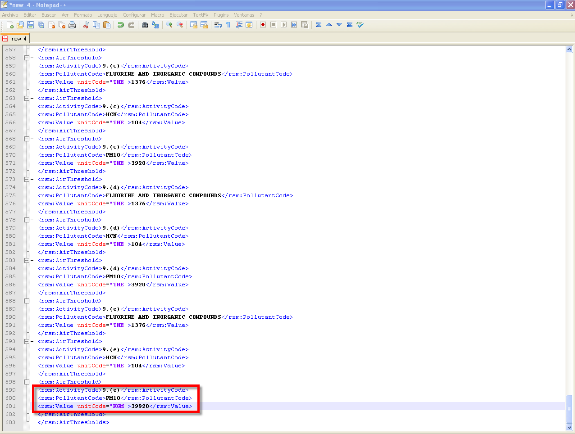

  - Save the file in your local drive as EPRTR_AirThresholds.xml (keep the same name)

Editing process for NUTS code list
When new MS or countries will participate of the E-PRTR directive in order to validate the location of their facilities reported they have to be included their NUTS at level 2 and/or level 3 in the code list. It is important to have in mind that current NUTS code list has been generated from the GISCO NUTS 2006 spatial data that you can download at GISCO web site:
http://epp.eurostat.ec.europa.eu/portal/page/portal/gisco/popups/references/administrative_units_statistical_units_1

Calculation of NUTS geographical envelopes:
The calculation of the geographical envelope of the NUTS of interest is needed to edit the XML properly.
The geographical envelope of a NUTS polygon is defined by the minimum bounding rectangle, is an expression of the maximum extents of a 2-dimensional object (polygon) within its 2-D (x, y) coordinate system, in other words min(x), max(x), min(y), max(y).
See the capture below for a sample of envelope of a french NUTS level 3.
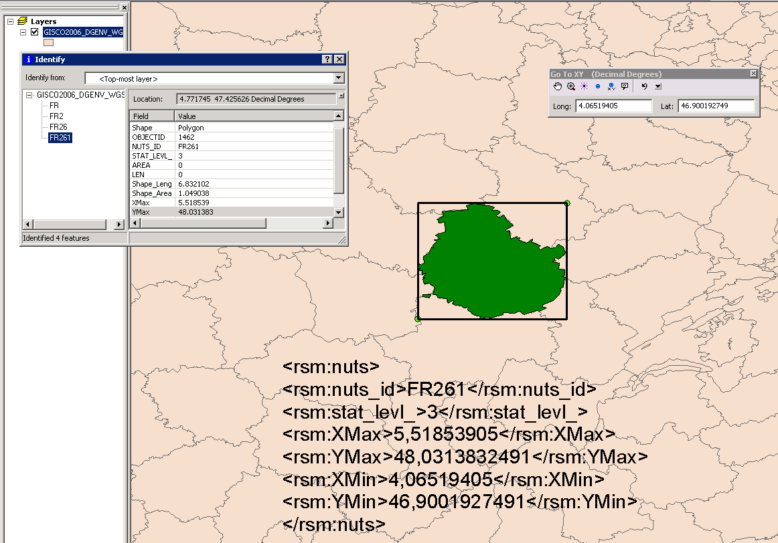
This calculation takes place in the GIS software ArcGIS. These are the steps needed to do this update:
- Add the feature class GISCO NUTS 2006 in WGS 84 spatial reference system in ArcMap.
- Add four fields to the GISCO NUTS 2006 in ArcMap:
  - XMax (Type: Double)
  - YMax (Type: Double)
  - XMin (Type: Double)
  - YMin (Type: Double)
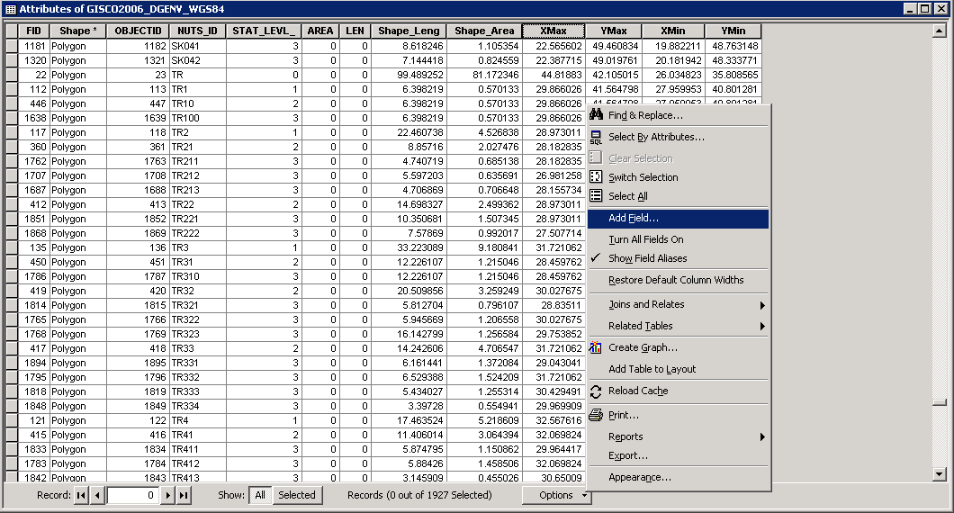
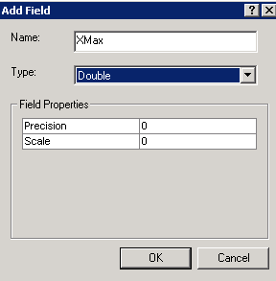

- Calculate fields:
In order to calculate fields an operation should be run in ArcMAP.
  - Choose the “Field Calculator” option with right click on the field to be calculated. See screenshot:
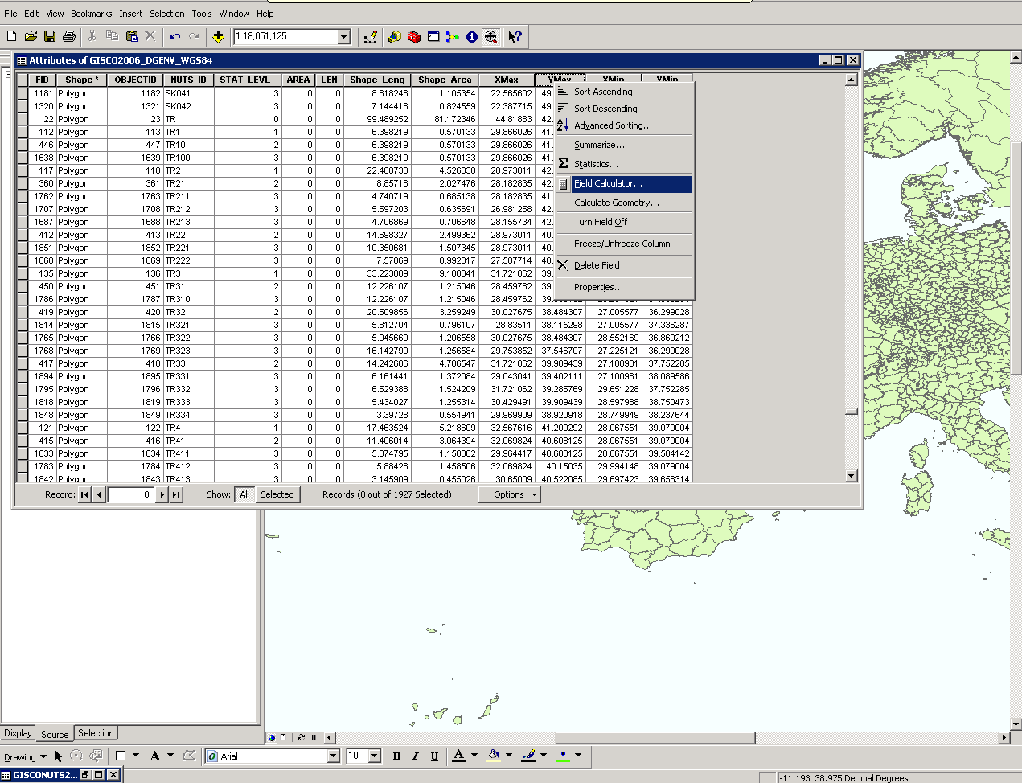
  - Run the following snippet with the “Advance” option checked in the “Field Calculator” dialog:
Pre-Logic VBA=
Dim Output As Double
Dim pPoly As IPolygon
Set pPoly As [shape]

Field name=
pPoly.Envelope.Xmax/Ymax/Xmin/Ymin*

Note *: You have to include the appropriate value to be calculated.

See screenshot:
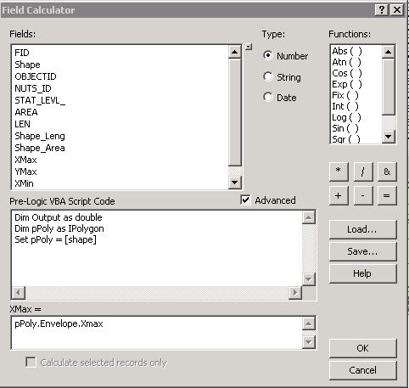
- Export feature class table to txt file from ArcMap.
This will allow opening the data in a text editor to edit the XML file as corresponds.
See screenshots:
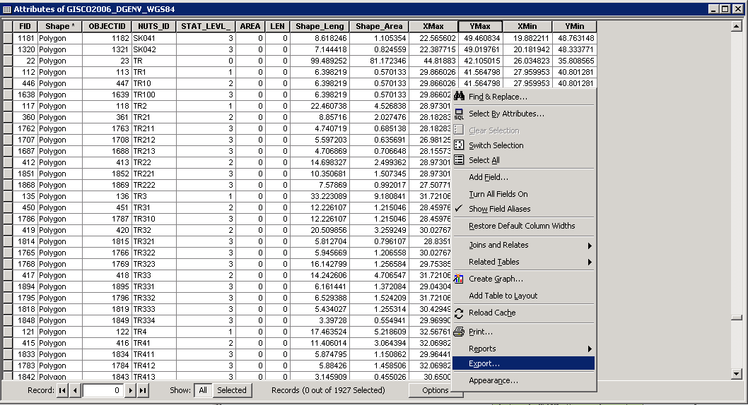
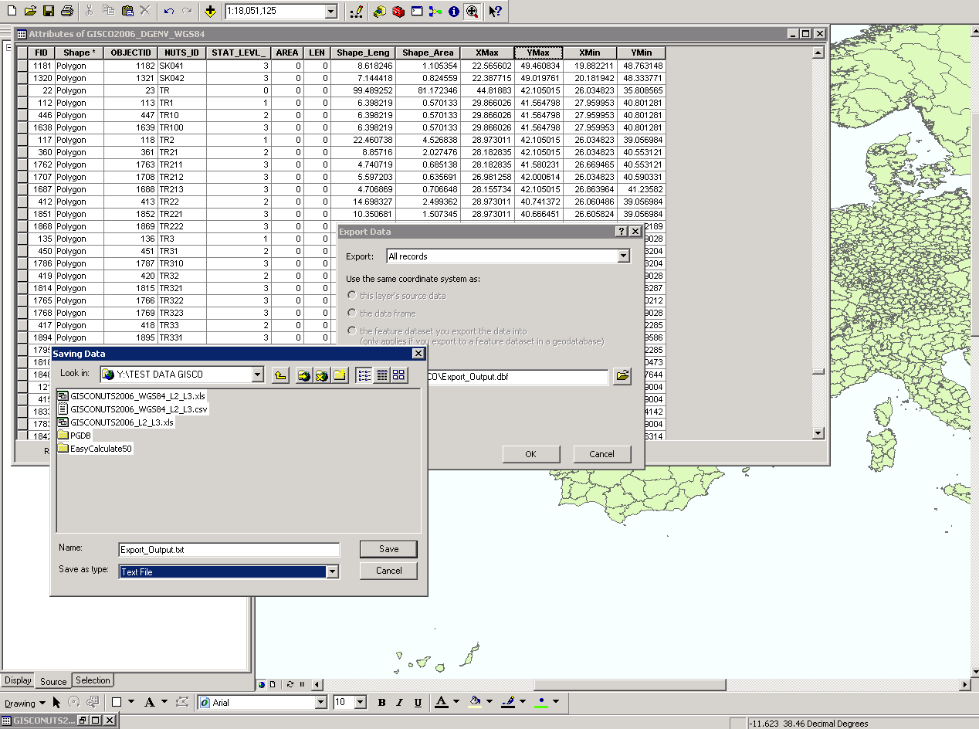

Upload process into CDR
After the edition of the XML, the updated XML has to be uploaded into CDR EIONET.
- Log on into http://converterstest.eionet.europa.eu/do/uplXmlFiles
- Select the XML file in this case: EPRTR_AirThresholds.xml

See screenshoot:
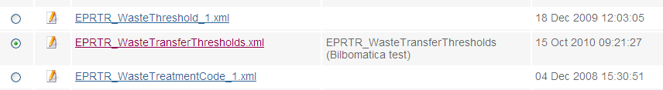

- Push the DELETE button above the list of XML files.
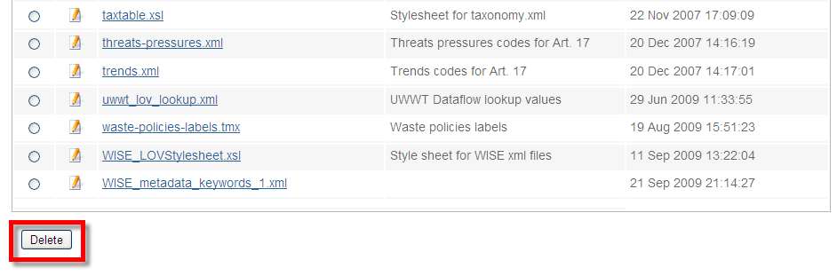

- Once the file has been deleted, it is the time to ADD the updated XML that you have it in local.
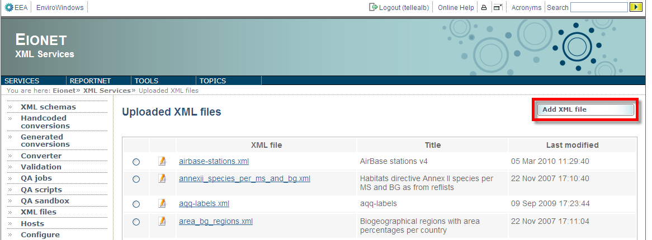
- Click on the ADD button of http://converterstest.eionet.europa.eu/do/uplXmlFiles

- Click the UPLOAD button and the XML will be successfully updated:
